Visualization Metaphors for Multi-modal Meeting Data
Vedran Sabol1, Christian Gütl2, Thomas Neidhart3, Andreas Juffinger3, Werner Klieber1, Michael Granitzer1

1Division Knowledge Discovery
Know-Center Graz
Inffeldgasse 21a
A-8010 Graz
vsabol@know-center.at
mgrani@know-center.at
wklieber@know-center.at
2Institute for Information Systems and Computer Media
Graz University of Technology
Inffeldgasse 16c
A-8010 Graz
cguetl@iicm.edu
3Knowledge Management Institute
Graz University of Technology
Inffeldgasse 21a
A-8010 Graz
thomas.neidhart@tugraz.at andreas.juffinger@tugraz.at

Abstract: The MISTRAL system, a service oriented architecture for semantic extraction of multimedia data from meeting recordings is described shortly. It improves on other similar systems by extracting a variety of semantic metadata from one media type and integrating it with concepts derived from other media types, as well as by adding inference capabilities to resolve ambiguities and further enrich extracted data. On top of this state-of-the-art extraction functionality a number of semantic-based, cross-modal visual applications for exploration and retrieval of extraction results were developed. Three selected applications, implemented upon the MISTRAL’s semantic application architecture, are presented and described into detail in this paper.

1 Introduction
Multimedia data has a rich and complex structure in terms of inter- and intra-document references. Its potential is severely limited unless effective methods for semantic extraction and semantic-based cross-media exploration and retrieval can be devised. Today’s leading-edge techniques in this area are working well for low-level feature extraction and, to a certain degree, for concept recognition and detection. However, they are focusing on narrow aspects of isolated collections of multimedia data, and are often dealing only with single media types.
In the MISTRAL project a service oriented system architecture for measurable, intelligent and reliable semantic extraction and retrieval of multimedia data (short MISTRAL) was developed. MISTRAL improves on these aspects by extracting a variety of semantically relevant metadata from one media type and integrating it with concepts derived from other media types. MISTRAL focuses on innovative, semantic-based cross-modal exploration and retrieval techniques employing concepts at different semantic levels. On top of this inference capabilities are provided, enabling MISTRAL to resolve ambiguities and further enrich extracted semantic data. Retrieval results based on semantic and cross-modal techniques contribute to a significant improvement of human-computer interaction in multimedia retrieval and exploration applications.
According to [RN01] meetings are becoming increasingly important for organizations in daily working processes. Electronic meeting systems has been an active research subject for a long time and various supportive tools and technology have been developed for any phase of the meeting live-cycle. [TH77] [Nu91] [RNB07]. In particular, meeting recording, their automated semantic annotations and meeting retrieval have become of great interest over the last view years in order to archive, explore, access and analyze meeting information [PGB04] [La05], [Ak06], [Ri05] [RQS04] [CAP01]. In the light of that, we have decided to focus on the “Meeting” application domain within the MISTRAL project. To demonstrate the capabilities of the MISTRAL system a number of semantic applications was developed which facilitate retrieving, browsing and exploring extracted meeting information. The focus of this paper is on these client applications and visualization techniques they employ.
The paper is organised as follows: the rest of this chapter describes some related projects; chapter two introduces MISTRAL's architecture in more detail; chapters 3, 4 and 5 describe different visual applications; chapter 6 and 7 conclude and discusse some further development possibilities.

1.2 Related work
In the M4 project [M404] a demonstration system for structuring, browsing and querying of an archive of automatically analysed meetings was developed. The system offers speech transcription, recognition of gestures and actions, multimodal identification of persons, stream-based multimodal integration, as well as a demonstrator system for browsing and accessing information from an archive of processed meetings. The demonstrator system includes a multi-modal indexing and retrieval applications and a visual application (the Ferret browser) for browsing of a single meeting.
The MARVEL [MAR] system focuses on development of generic, state-of-the-art multimodal machine learning techniques for bridging the semantic gap for multimedia content analysis and retrieval. It automatically annotates multimedia making it possible to later search and retrieve content of interest. Although MARVEL does not focus on client applications, it provides a Web interface for retrieval tasks.
NIST Meeting Recognition Project [MRP] concentrates on supporting the development of audio and video recognition technologies in the context of human-human meetings such as person/object identification/tracking, text extraction, gesture recognition etc. The project also includes an extensive data collection effort.
2M2Net [YZL01] is a framework for multi-modal retrieval of multimedia data in multimedia digital libraries. The retrieval is performed based on the integration of multi-modal features including both semantic keywords (concepts) and media-specific low-level features as well as inter- and intra-document correlations. A Web client application supports keyword-based semantic retrieval and feature-level retrieval through submitting of examples.
LiteMinutes [CBG01] is a web-based system relying on the Web and email for creating, revising, distributing, and accessing multimedia information recorded during meeting. Supported media include the video recorded during the meeting, presentation slides and text notes taken on wireless laptops. LiteMinutes does not focus on extraction of metadata from multimodal content.
MAVS (Multilingual Audio Visual Search) [MAV] is a multimedia retrieval system which relies on voice recognition technology for searching in archives of multimedia content. It allows the location of words, phrases and concepts within any multimedia content, typically videos. It provides an interactive GUI for presenting and browsing retrieval results. By clicking on a result, the system will play the corresponding part of the video.
AMI (Augmented Multi-party Interaction [AMI] is concerned with new multimodal technologies to support human interaction, in the context of smart meeting rooms and remote meeting assistants. Several applications for searching and browsing meetings have been designed as part of an integrated multimodal group communication. These include applications for Meeting Dialog and Argumentation Tracking, Compressed Meeting Player, Participant Influence and others.

2 The MISTRAL Project at a Glance

2.1 The MISTRAL Core System
The amount of multimedia data available world-wide is huge and will continue its rapid growth in the foreseeable future: According to a study conducted by P. Lyman and H.R. Varian at the University of California Berkeley, in 2003, an amount of 800 Megabytes of new data is currently created per year and per capita, based on an assumed world population of 6.3 billion. The same study estimates that of a total amount of 5 Exabytes of information available world-wide, about 92% exists in electronic form, with a 170 Terabyte share being available on the Internet. Image, video and audio data is becoming the predominant form of information forming this global asset. Multimedia data has a rich and complex structure in terms of inter- and intra-document references (e.g. text refers to images in the same document, audio on one internet server punctuates video on another internet server) and can be an extremely valuable source of information. However, this potential is severely limited until and unless effective methods for semantic extraction and semantic-based cross-media exploration and retrieval can be devised. Today’s leading-edge techniques in this area are working well only for low-level feature extraction, and are focusing on narrow aspects of isolated collections of multimedia data, and are dealing only with single media types. In contrast to these techniques, the goals for MISTRAL project as a whole were defined as follows:
- (Semi-)Automatic object recognition and extraction of semantically relevant metadata at different semantic levels from different types of media. Integration of semantic concepts derived from different media types.
- Focusing on most innovative, semantic-based cross-media exploration and retrieval techniques employing concepts at different semantic levels. Allowing users to search and navigate across different types of media.
- Addressing the specifics of multimedia data in the global, networked context employing standards and semantic web technologies (e.g. XML, RDF, MPEG-7, SOAP, WSDL, etc.). Usage of Web services as a base for the software infrastructure.
- Improved human computer interaction through development of cross-media retrieval applications based on semantically enriched metadata, intuitive user interfaces and leading-edge visualization techniques
- Development of a benchmarking system with an integrated shared data repository.
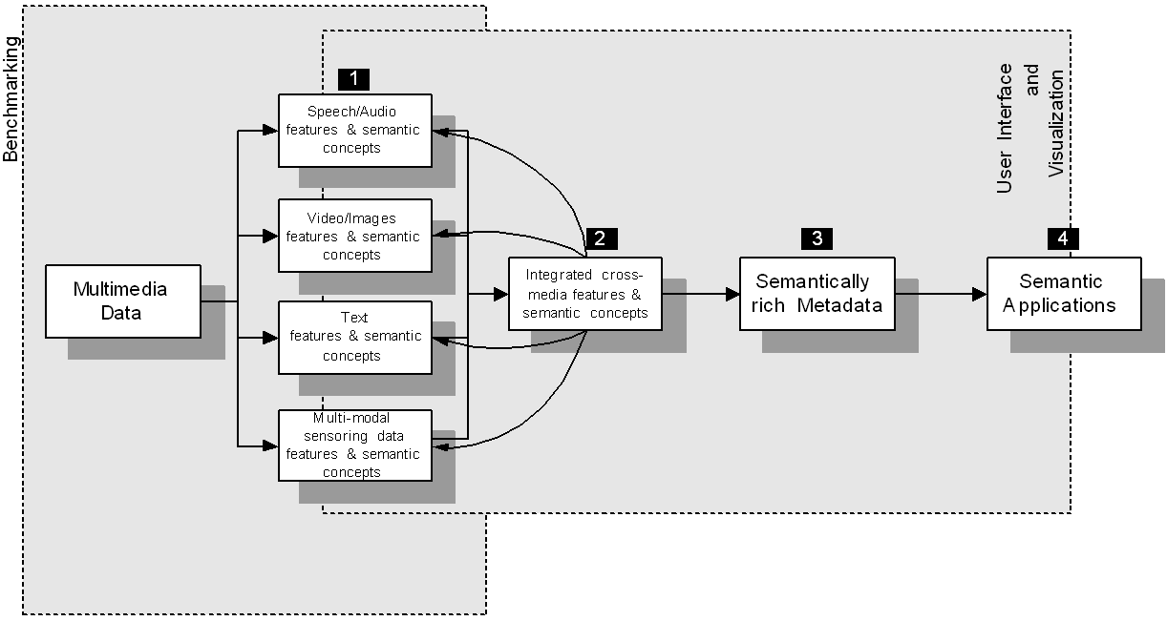
Figure 1 MISTRAL high level architecture
The high level architecture of MISTRAL is displayed in Figure 1. MISTRAL consists of a number of functional services, also called units, which are subdivided into horizontal and vertical services. Horizontal services define a flow of actions for performing extraction of feature and concepts from the recorded materials. Vertical services act as supportive services, which do not offer analysis capability, but are necessary for the system to operate. At the beginning of horizontal services are metadata extraction units (1) which process the recorded multimedia data and extract feature and concepts separately for each modality. The extracted metadata for different modalities are integrated by multi-modal merging unit (2). The role of the semantic enrichment unit is to apply an inference model is to check the validity of extracted metadata. The results of the horizontal process are used by semantic applications (4). Vertical services include a benchmarking module with a storage subsystem as well as user interfaces and visualization components.
Since a completely generic system would be extremely difficult to realize (because of resource and technological considerations) an application domain was chosen and defined in order to focus the development of extraction algorithms: The “Meetings” application domain describes an abstract scenario and concentrates on video materials showing one or more persons talking or discussing about a subject. Additionally to recorded video materials accompanying documents, such as PowerPoint slides are also processed by the system. The capabilities of services (units) are described only briefly without discussing algorithm and implementation details (since this is not the main topic of the paper):
- Video Unit is a framework for person detection, tracking and recognition from video data. By means of the integral data structure the features are real-time computable enabling a real-time implementation of all three modules.
- Audio Unit works with multi-channel audio signals, recorded by a linear micro-phone array. First it estimates the background noise, suppresses it as much as possible, and extracts the following speech-related features: voice activity (VAD) regions, speaker's position, speaker's gender, speaker indexing.
- Click data (sensory data) unit monitors and saves all user input such as mouse clicks and keystrokes and tags them temporal information, active application information, and grabs text data currently displayed by the application for further processing.
- Text unit employs text mining and retrieval techniques to extract named entities, topics and concepts and to provide searching functionality for text data.
- Multi-modal merging unit fuses and synchronizes features extracted from different modalities (e.g. Video, audio and text) and produces combined extraction results in a MPEG7-style format.
- Semantic enrichment unit provides inference capabilities for detecting and solving inconsistencies from the different extraction units and adding new semantic concepts to the data.
- Integration of components through shared MPEG7 data structure, a data access and storage component, a benchmarking system and client applications for data access and data annotation.
- Applications: A number applications for retrieving and browsing results provided by MISTRAL were implemented. This paper describes three selected applications.

2.2 The MISTRAL Semantic Application
As already stated before, there is an evident need for indexing, retrieving and accessing meeting recordings and related meeting documents for diverse organizational purposes. In addition meeting analysis has been an interesting and important research topic for long time, which can greatly benefit from meeting analysis tools. This has motivated us to focus the MISTRAL Semantic Application on meeting information retrieval and visualization.
In the light of that, some relevant requirements for the MISTRAL Semantic Application can be summarized from [GG 05] in the following.
- Important requirements from the information need viewpoint are:
(a) organizational information (meeting data and project relevant information), (b) participant information (attendees, roles and activities of participants, spatial-temporal information), (c) meeting content and time-specific information (speech-to-text and related documents, topics and content abstracts), (d) number and frequency of topics related to a meeting, a project or a participant, and (e) temporal occurrences of features and concepts.
- Important requirements from the functional viewpoint are:
(a) Meeting information retrieval on the one hand embraces the definition of functionalities in order to identify, to pre-process, to access and to recall relevant meeting information form the MISTRAL Meeting Repository. On the other hand, the system has to manage representations of the meeting data and build data structures in order to support users’ information needs. (b) In particular, information visualization is very important for a useful information access according to the users’ information needs. Based on the information needs stated so far, the system has to provide search result presentation as a linear list in table form, information-structure-dependent visualization by metaphors for hierarchies, graphs, similarities, and time series. In addition, meeting recordings and meeting recording annotations have to be properly visualized by the system.
Based on that, the system architecture of the MISTRAL Semantic Application is depicted in Figure 2 and briefly discussed in the remainder of this section. The Preprocessor accesses the MISTRAL Meeting Repository to extract relevant data and to transform data structures for further usage. It feeds the Modeler with statistic information to build models about meetings and meeting participants. The Preprocessor also delivers extracted meeting recording information and related meeting document information to the Meeting Information Indexer in order to build diverse indices for the retrieval process. The Retrieval module performs search requests from and delivers the search results back to various visualization tools. It is worth to mention that also a secured direct access to meeting information by means of the Preprocessor is necessary for the purpose of specific meeting analysis tasks.
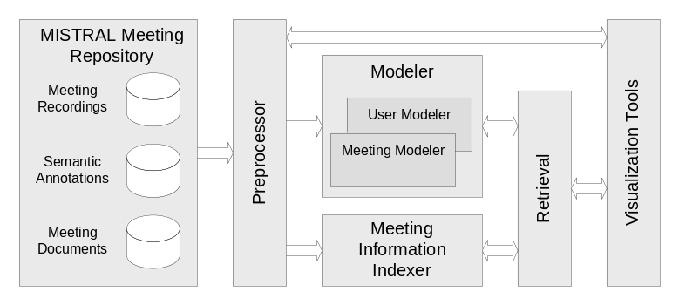
Figure 2: System Architecture of the MISTRAL Semantic Application

3 General Meeting Information Visualization
The aim of MISTRAL’s General Meeting Information Visualization is to provide a comprehensive and well-structured view of meeting search results. Unlike other existing meeting browser approaches (see for example [La05], [Ri05] and [Ak06]), we have decided to apply a search-engine-like user interface for meeting information search and retrieval. Based on diverse information needs given by various user scenarios, search queries can be applied on different granularities - entire meetings and speaker segments – and search results are also need to be presented on the same level of meeting granularity. To narrow down to the visualization aspects, relevant meeting search results and other linked information corresponding to specific meetings are clustered together and presented as logical units. Such logical units include general information about the specific meeting, relevant meeting segments and for each meeting segment related meeting documents (for example agenda, presentation slides and the like).
Figure 3 depicts exemplarily the meeting information structure and layout for search results at the granularity of entire meetings. Each meeting result representation starts with a header and information about the meeting title, a short meeting title, the topic about the meeting, meeting date and location. Meeting segments and their related meeting documents are followed in the search result representation. Because of the search granularity of the meeting level, only one relevant meeting segment for each meeting can exist. A meeting segment is represented by the segment title, an excerpt of the meeting transcript, information about the meeting participants and the available meeting recording data streams. The meeting participant section comprises for each participant name, a picture and three icons which symbolize whether the participant is visible, audible and main actor in the segment. The meeting recording section provides information about the duration of the meeting and information about the start time, end time and the duration of the meeting segment. Furthermore, information about the available meeting recording streams is given, and thumbnails convey a visual impression about the segment. Finally, the related meeting document section depicts documents which are actively used in the meeting.
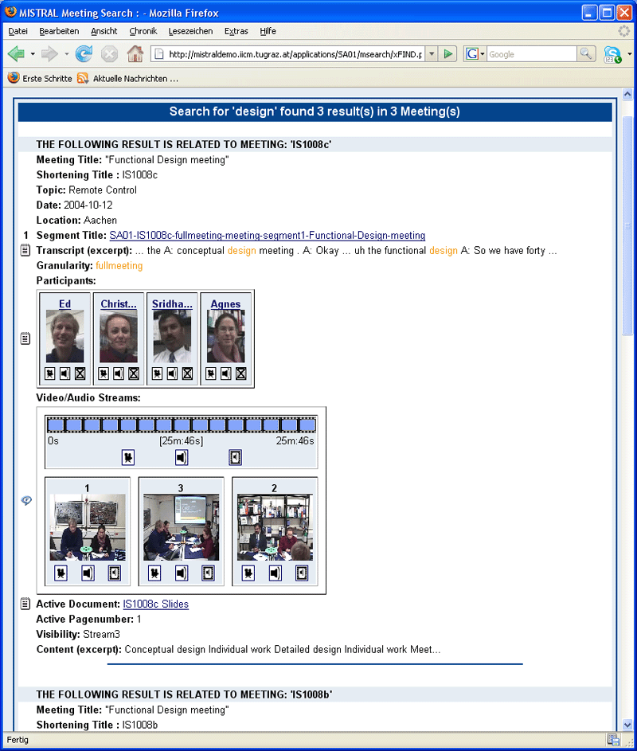
Figure 3: Search Result Visualization: Granularity of entire Meetings

4 Explorative Meeting Information Visualization
The aim of the Explorative Meeting Information Visualization (EMIV) is to deal with a large variety of meeting specific data extracted from multi-modal meeting recording streams by the MISTRAL core system and to offer various visualization metaphors which can also be combined for meeting analysis. EMIV is based on a generic solution approach, which is designed to be flexible in terms of interoperability and different scenarios. The application was developed in Java because of reasons of platform independence. An architectural overview is shown in Figure 4. The system is split into a server-side part and a client-side part.
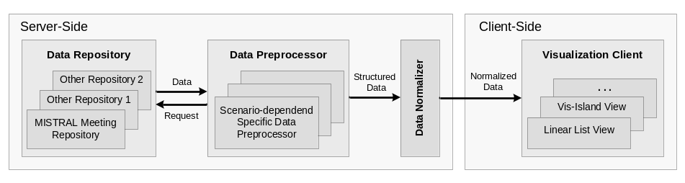
Figure 4: Architectural Overview of EMIV
The server-side modules deal with necessary data processing tasks of the visualization application. In order to gain highest flexibility for various application scenarios, specific instances of the Data Preprocessor can request data from diverse data repositories, process and structure it for further usage. Within the MISTRAL project, we have implemented one specific data processor. It can simply send different types of query request to the MISTRAL retrieval system and structure the results for further usage. In addition to that, for very specific visualization scenarios it can also apply text analysis to gain similarity values based on meeting content or speaker content. At the end of the data processing chain at the server-side, the Data Normalizer converts the structured data in a normalized form for further usage at the client-side. For this first version we have focused on multi-dimensional data structures. The Visualization Client has implemented some general management components, such as data handling and caching, communication infrastructure and observer for synchronization of different visualization views. Furthermore, the application is flexible in terms of the simple integration of new visualization modules. The Visualization Client can either be used as stand-alone Java application or it can also be integrated in a web application as a Java applet.
An example view of EMIV’s Visualization Client is depicted in Figure 5. The basic elements for interaction and data exploration are described as follows: (A) The Filter and Control Panel enables users to select and deselect specific dimensions as well as specific data vectors in order to specify the actual data set for visualization and exploration tasks. (B) The Linear List view enables users to inspect the selected data dimensions of selected data vectors. Data set can be sorted by any active data dimension and the order of data dimensions can also be configured. (C) The Info Panel view enables users to get detailed information about a specific data vector which is marked in one of the other visualization views, such as the Linear List view. In general, observer and communication infrastructure enable to synchronize the marking of a specific data vector or the selection or de-selection of one and the same set of data vector over the visualization views. As more advanced visualization views we have implemented a Scatter Plot View and the VisIsland View. Information about or previous implementations and its application can be found for example in [An01]. Implementation results about the enhanced versions and its application in the domain of meeting information visualization will be discussed in the remainder of this chapter.
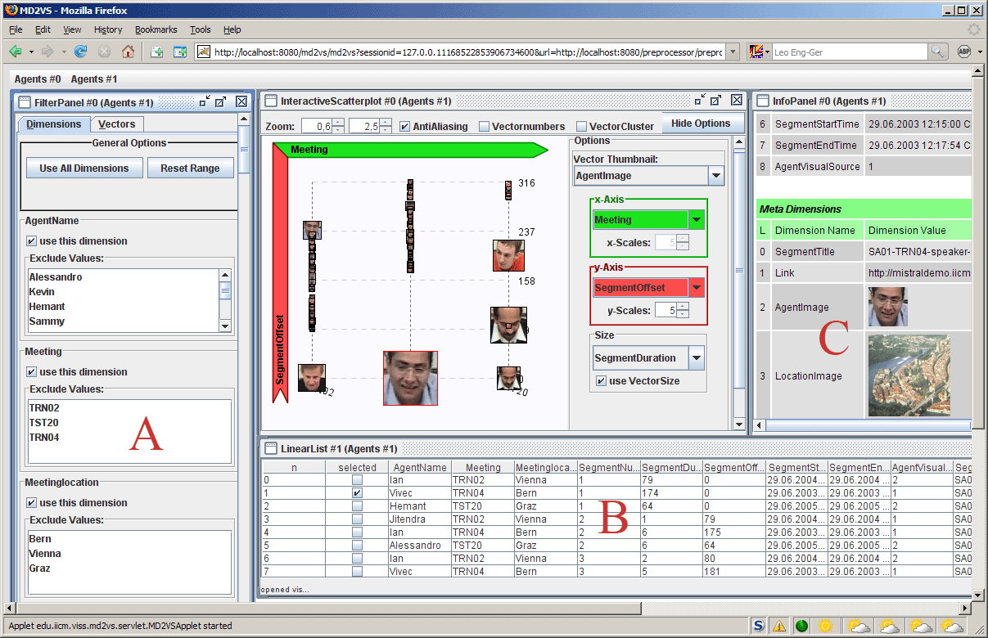
Figure 5: Example view of EMIV’s Visualization Client
The Scatter Plot view uses ordinate, abscissa, icons or pictures and their size to visualize 4 diverse dimensions of the multi-dimensional data in a two-dimensional plan. Users are free to choose any dimension from the data vector and assign them to one of the four visualization dimensions. In general, scatter plots are useful for graphically determining associations between selected dimensions. In the light of that users are able to specify specific visualizations in order to explore and review one ore more meetings.
To illustrate the high flexibility of the Scatter Plot view, some selected examples of a great variety of possible application scenarios are given as follows. The first example deals with the question how frequently a topic was addressed by meeting participants in a set of selected meetings. Figure 6 shows the graphical output: the dimension ‘meeting’ is assigned to the x-axis, the ‘number of occurrences’ of a specific topic is linked to the y-axis, and the pictures represent the meeting participants. A second application scenario addresses the review of speaker segment duration over the live-cycle of a specific meeting, as depicted in Figure 7 (‘segment duration’ is assigned to x-axis and ‘segment offset’ is assigned to y-axis). As a third example, the visualization of the temporal sequence of active speakers and related segment durations for selected meetings is given in Figure 8 (the ‘segment offset’ is assigned to the x-axis, ‘meeting’ is assigned to the y-axis, and ‘segment duration’ defines the size of the pictures).
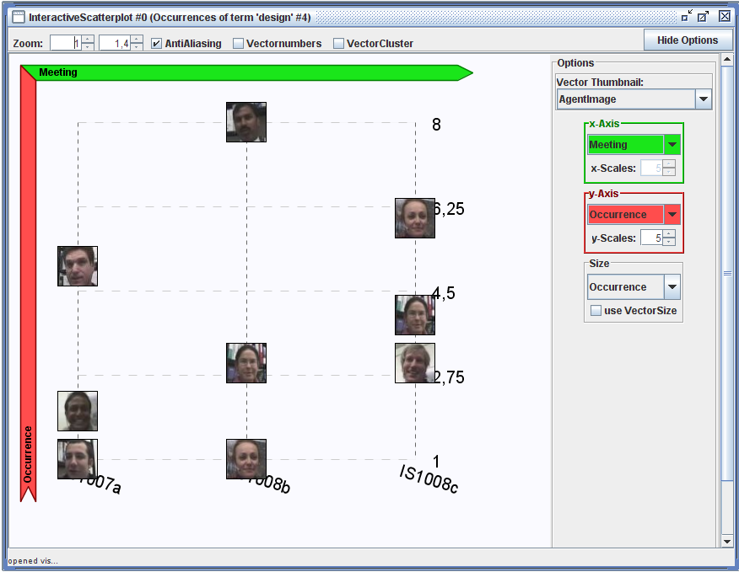
Figure 6: Occurrences of the topic ‘design’ in selected meeting by meeting participant utterances.
The VisIsland view is based on the visualization principle to place graphical representations of data vectors in accordance to their similarity in a two-dimensional plane. Consequently, similar data vector are spatial grouped and they can be represented as some sort of islands in the graphical view. Thus the VisIsland view enables to determine graphically similarity and dissimilarity of data vectors as well as to identify groups of similar objects. VisIsland views of the thematic, content-based similarity of meetings (see Figure 9) and cumulated utterances of meeting participants (see Figure 10) are given as examples in the context of meeting exploration.
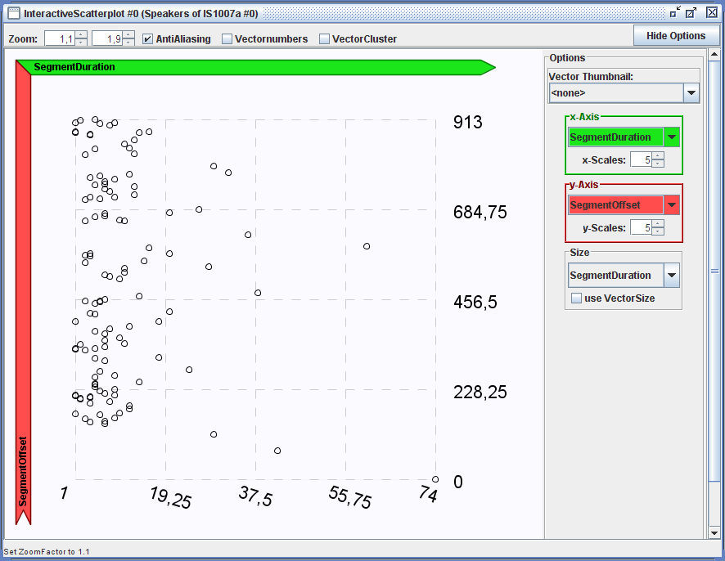
Figure 7: Review of speaker segment duration over the live-cycle of a specific meeting.
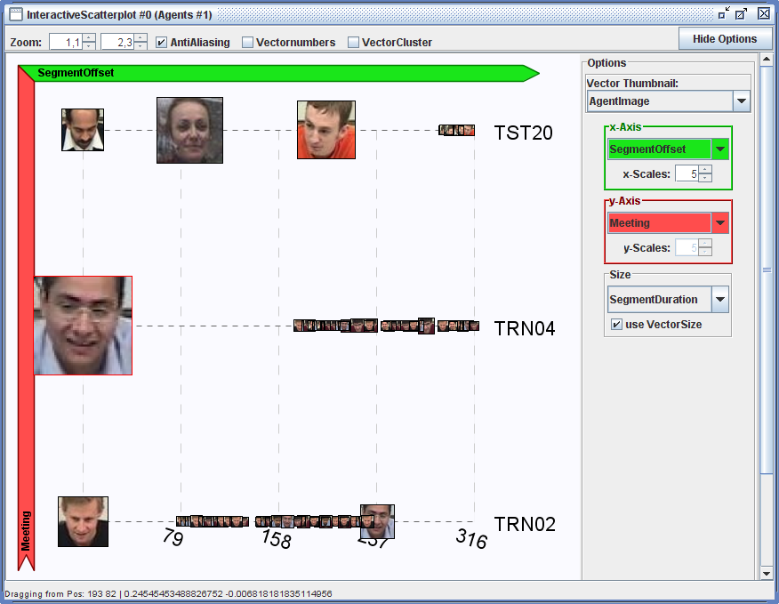
Figure 8: Visualization of the temporal sequence of active speakers and related segment durations for selected meetings.
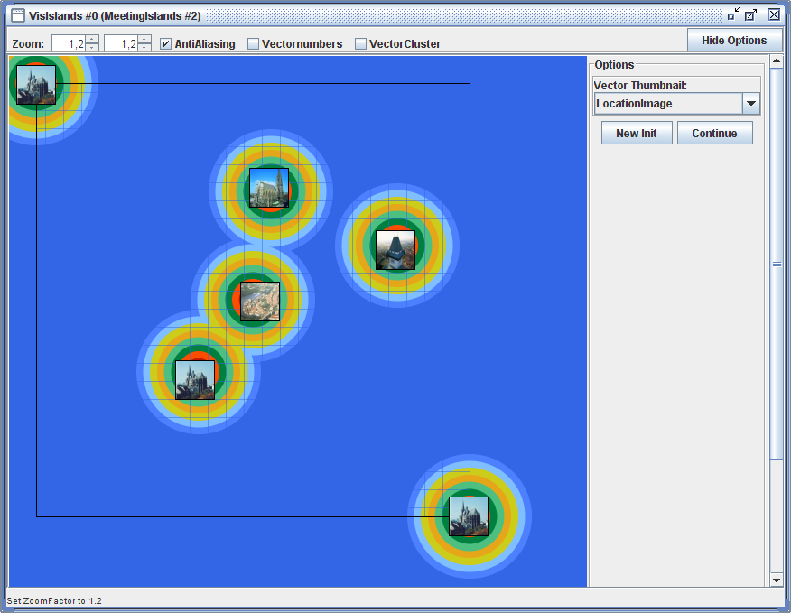
Figure 9: Thematic, content-based similarity of meetings.
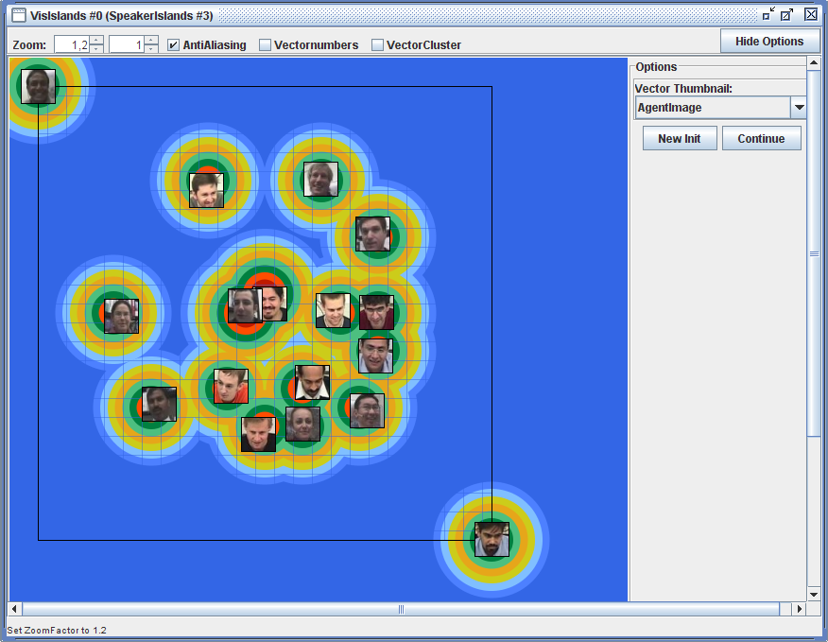

Figure 10: Thematic, content-based similarity of cumulated utterances of meeting participants

5 Visual Conversation Analysis
The main goal of the Visual Conversation Analysis (VCA) tool is to visualize communication patterns between participants of a meeting and discover temporal and causal relationships, such as activity of speakers and topics, who talks about which topics, who engages in discussions with whom, relevance of external resources to topics and persons, etc. Input data for the application are the results of MISTRAL automated extraction, possibly extended manually using the MISTRAL annotation application. The data can be accessed through a Web service or are given in the form of a MPEG7-style file.
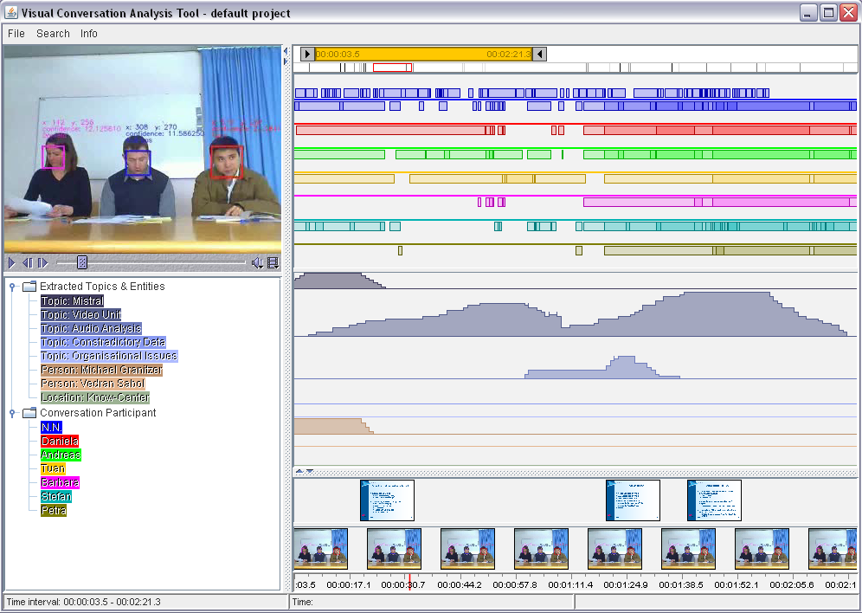
Figure 11 Visual Conversation Analysis Tool
The resulting visual application (Figure 11) is designed to unveil the following information:
- Speaker’s actions and events over time. Typically speaking activity is visualised enabling the user to see at which points of a meeting a person was holding a monologue, when there was a dialog between two participants, or when a discussion involving more participants was going on.
- Topics discussed during the meeting as well as other entities mentioned during the discussion or present in accompanying materials (typically PowerPoint slides), such as: organizations, persons, places, temporal information etc.
- Usage of other resources such as PowerPoint slides or external documents, as well as the storyboard of the video recorded during the meeting.
The application also includes a video player for playing the original video material recorded during the meetings.
A software architecture (see Figure 12) for synchronizing different visual components, as well as shared data model for temporal actions and events were implemented. Their purpose is to allow for fast, synchronized filtering, selection, zooming and navigation. The synchronization framework and the shared data model are used by a number of temporal visualization components, most of them having a shared temporal axis. Currently implemented are the following (see Figure 11):
- Temporal activity component which visualizes presence or absence of actions and events. This component (on the upper right) is configured to visualize actions, primarily speech activity, of meeting participants.
- Temporal intensity component which visualizes the intensity of an activity or a number of simultaneous events. This component (in the centre, right), is configured to visualize topics of discussion.
- Component for temporal visualization of icons (i.e. image thumbnails), such as PowerPoint slides, captured video frames, time information, etc. Two such components are employed (on the lower right): the upper displays PowerPoint slides, the lower one the storyboard.
Entities such as meeting participants, extracted topics and named entities are colour-coded. Meeting participant are colour-coded by bright intensive colour. Extracted topics and entities are encoded by less intensive, pastel colours, whereby different shades of the same colour are used for different entities of the same type (i.e. topic, person, location, etc.). A dedicated visual component, a legend in the form of a tree (on the lower left), is used to specify the colour-coding. For temporal navigation and zooming purposes a dual scroll (top right) bar is employed: choosing of a time interval (i.e. a temporal zooming function) is achieved by operating the higher and lower scroll bar widgets, while by sliding the scrollbar the chosen temporal window is smoothly moved back and forward in time. A search result bar (bellow the dual scroll bar) displays found events and actions spread along a temporal axis. A mouse-over effect caused one found event to be highlighted in red. Clicking on that result will trigger a smooth, animated navigation to the time interval covered by that event.
VCA is a Java 1.5 application developed using Swing toolkit, Java2D library and Java Media Framework (JMF 2.1.1e). The application is currently under development and will be extended with further visual metaphors (information landscapes, a theme river-style visualisation, etc.). Another goal is to apply the VCA tool on data extracted from communication scenarios other than meetings, such as newsgroups and discussion forums, email exchange, instant messaging data and similar.
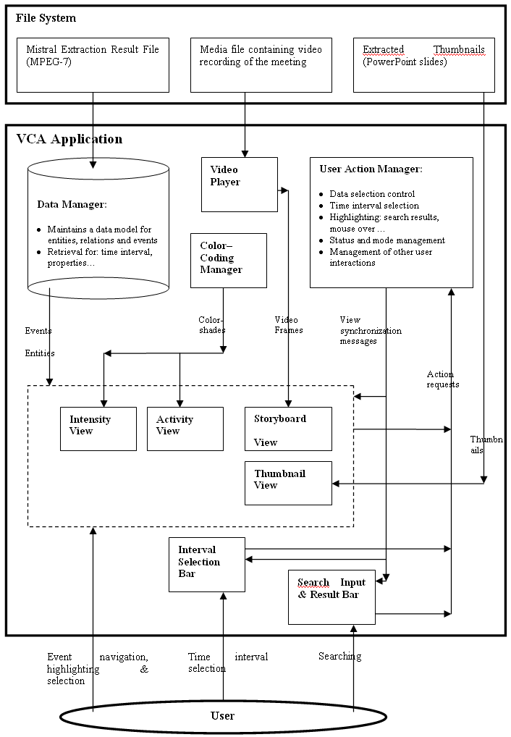
Figure 12 VCA architecture

6 Conclusions
In this paper we have first introduced the MISTRAL project in short, in which a service oriented system architecture for semantic extraction of multimedia data (audio, video and text) was developed. MISTRAL improves on other similar systems by extracting a variety of semantically relevant metadata from one media type and integrating it with concepts derived from other media types, as well as by adding inference capabilities it to resolve ambiguities and further enrich extracted data. MISTRAL’s state-of-the-art extraction techniques focus on recordings of meeting videos recorded during the project.
On top of this service-based, multi-modal extraction functionality a number of innovative, semantic-based, cross-modal visual applications for exploration and retrieval of extraction results were developed. Retrieval results based on semantic and cross-modal techniques, employing concepts at different semantic levels, contribute to a significant improvement of human-computer interaction in multimedia retrieval and exploration applications. Three selected prototype applications, implemented upon the MISTRAL’s semantic application architecture, were described into detail in this paper.
Due to the fact that presented visual applications are still in advanced stages of development we can not provide meaningful evaluation results based on user tests at this time. However, we have been collecting feedback periodically during the project through heuristic evaluation and by presenting the prototypes to groups of experts at different stages at development. Extensive user testing is planned and will be performed and its results published in the future.

7 Future Work
In the future some of technologies developed in within the MISTRAL project, in particular the text extraction unit and the VCA application, shall also target application domains other than meetings which posses a highly dynamic character. One application domain also dealing with communication and lively information exchange are social networks and selected social applications in the context of Web 2.0. Newsgroups and discussion forums, blogs, wikis, instant messaging, email traffic and similar services are the just some potential application targets. Another possible area of application is the publishing sector: diffusion and resonance of news, effects of published information (for example stock prices) with the goal of visually discovering trends, “hotness” of topics, events, activities of different entities (such as persons and organisations), as well as causal relationships.
Those topics are addressed in the AVALON [AVA] research project, where textual information is semantically enriched using text extraction and ontology learning methods. Each textual information (e.g. forum posts, news items) is semantically annotated and aligned over time. The goal is to identify trends and to allow users a deep analysis of the underlying topical structure over time. Thus, the visualisation metaphor remains similar to the metaphor proposed in this paper, while the underlying data and pre-processing mechanisms are changed. Also, AVALON will lead us further to enhance the capabilities of the VCA application in terms of visual inference allowing users to deduce new knowledge from information aligned in time.

8 Acknowledgements
The project results have been partly developed in the MISTRAL project (Measurable intelligent and secure semantic extraction and retrieval of multimedia data - http://www.mistral-project.at) and the AVALON (Acquisition and Validation of Ontologies) project. MISTRAL and AVALON are financed by the Austrian Research Promotion Agency (http://www.ffg.at) within the strategic objective FIT-IT under the project contract number 809264/9338 (MISTRAL) and 810803 (AVALON).
We grateful acknowledge the following resources for meeting data provision: (1) The AMI Meeting Corpus, with have been released publicly under the Creative Commons Attribution NonCommercial ShareAlike 2.5 License. (2) I. McCowan, S. Bengio, D. Gatica-Perez, G. Lathoud, F. Monay, D. Moore, P. Wellner, and H. Bourlard, "Modeling Human Interaction in Meetings", in Proc. IEEE Int. Conf. on Acoustics, Speech and Signal Processing (ICASSP), Hong Kong, April 2003. For further information see also http://www.m4project.org and http://mmm.idiap.ch.
Last but not least we also grateful acknowledge important contributions to the Explorative Meeting Information Visualization by Helmut Mader who currently work on his Master Theses about multi-dimensional information visualization.

References
[AMI] Augmented Multiparty Interaction (AMI), http://www.amiproject.org
[An01] Andrews, K., Gütl, C., Moser, J., Sabol, V., Lackner, W.: Search Result Visualisation with xFIND. Proc. UIDIS 2001, IEEE Computer Society Press, Zurich, Switzerland, 2001, pp. 50 - 58
[Ak06] Akker, H. op den: Question Answering as Meeting Browser Interface. Twente Student Conference on IT, University of Twente, 2006, last visit 2007-01-15, http://referaat.ewi.utwente.nl/documents/2006_04_C-Intelligent_Interaction/2006_04_C_Akker,H.op%20den-Question_Answering_as_Meeting_Browser_Interface.pdf
[AVA] AVALON, http://iwm.tugraz.at/research/projects/avalon
[CAP01] Costa, C.J., Antunes, P.A., Dias, J.F.: A Model for Organisational Integration of Meeting Outcomes. In Maung K. Sein, and others (Eds.), Contemporary Trends in Systems Development. Kluwer Plenum, 2001. (Papers from the Ninth International Conference on Information Systems Development, ISD 2000. ISBN: 0-306-46608-2).
[CBG01] Chiu, P., Boreczky, J., Girgensohn, A., Kimber, D., LiteMinutes: an Internet-based system for multimedia meeting minutes, Proceedings of the tenth international conference on World Wide Web, 2001, pages 140—149
[GG05] Guetl, C., García-Barrios, V.M.: Semantic Meeting Information Application: A Contribution for Enhanced Knowledge Transfer and Learning in Companies. In Proceedings of ICL, 2005.
[La05] Lalanne D., Lisowska A., Bruno E., Flynn M., Georgescul M., Guillemot M., Janvier B., Marchand-Maillet S., Melichar M., Moenne-Loccoz N., Popescu-Belis A., Rajman M., Rigamonti M., von Rotz D. & Wellner P. (2005) - The IM2 Multimodal Meeting Browser Family. Joint IM2 Technical Report, March 2005, 17 p.
[LH03] Lyman, P., Hal R.V.: "How Much Information", 2003. http://www.sims.berkeley.edu/how-much-info-2003
[M404] M4-Project: http://www.m4project.org/programme.html
[MAR] MARVEL: Multimedia Analysis and Retrieval System, Whitepaper, IBM T. J. Watson Research Center, http://www.research.ibm.com/marvel/Marvel%20Whitepaper.pdf
[MAV] MAVS, Prouse Science, http://www.prous.com/mavs/Home/index.asp
[MRP] NIST Meeting Recognition Project, National Institute of Standards and Technology,
http://www.nist.gov/speech/test_beds/mr_proj/index.html
[Nu91] Nunamaker, J.F, Dennis, A.R., Valacich, J.S., Vogel, D.R., George, J.F.: Electronic meeting systems to support group work: theory and practice at Arizona. Communications of the ACM, 34, 7, 1991, 40-61.
[PGB04] Pallotta, V.; Ghorbel, H., Ballim, A.: TOWARDS MEETING INFORMATION SYSTEMS: Meeting Knowledge Management. International Conference on Enterprise Information Systems (ICEIS 2004), 2004.
[RNB07] Rienks, R., Nijholt, A., Barthelmess, P.: Pro-active Meeting Assistants: Attention Please! AI & Society, The Journal of Human-Centred Systems. Springer-Verlag London Ltd, 2007, to appear.
[Ri05] Richter, H.: Designing and Evaluating Meeting Capture and Access Services. Dissertation, Georgia Institute of Technology, April 2005, last received 2007-01-09, http://www.smartech.gatech.edu/bitstream/1853/6933/1/richter_heather_a_2000505_phd.pdf
[RN01] Romano, N.C., Nunamaker, J.F.:Meeting Analysis: Findings from Research and Practice. Proceedings of the 34th Annual Hawaii International Conference on System Sciences, 2001.
[RQS04] Rose, R.T., Quek, F., Shi, Y.: MacVisSTA: a system for multimodal analysis. Proceedings of the 6th international conference on Multimodal interfaces, 2004, 259 – 264.
[TH77] M. Turoff, M., Hiltz,, S.: Meeting through your computer. IEEE Spectrum, May 1977, p. 58-64.
[YZL01] Yang, J., Zhuang, Y. T., Li, Q., Search for Multi-Modality Data in Digital Libraries, in Proc. of 2nd IEEE Pacific-Rim Conference on Multimedia, pp. 482-489, China, 2001

